Step One:
First take the 97 letters of K4, and starting with a “hole” (O) in the upper left corner, arrange the rest of the letters in groups of 3:4:5, as per “The Golden Ratio” –phi - 1.618 – described in the Rhind Papyrus in relation to pyramid building. (3:4:5 describes right triangles – not the Golden Ratio, but 1.618 is what got me started on this – my math facts may be fuzzy and blurring together as it’s been a while since I studied Egyptian Mathmatics. Sorry - the point is the result, not my math “un-facts”)
(Since K4 is probably still encrypted, (?) I am just inserting K4 “as is” … but perhaps this process will provide something to experiment with for those who have time/are willing/see this as promising. I haven’t had time to go through every permutation and decryption suggestion … yet.)

O
BKR
UOXO

GHULB
SOL
IFBB
WFLRV
QQP
RNGK
SSOTW
TQS
JQSS
EKZZW
ATJ
KLUD
IAWIN
FBN
YPVT
TMZFP
KWG
DKZX
TJCDI
GKU
HUAU
EKCAR (cont’d)

Step Two:
Then, leaving the “O” at the top (K4 is just the “apex of the pyramid”), stagger the letters out, forming a pyramid.

O
BKR
UOXO
GHULB
SOL
IFBB
WFLRV
QQP
RNGK
SSOTW
TQS
JQSS
EKZZW
ATJ
KLUD
IAWIN
FBN
YPVT
TMZFP
KWG
DKZX
TJCDI
GKU
HUAU
EKCAR

(cont’d)
Step Three:

(this one is the most intriguing – see next page)

Superimpose the newly formed “pyramid text” OVER the K1 – K3 PT. (LAYER TWO) Curiously, the text ENDS right before the question mark at the end of K3, and looks like it was MADE to fit there!
Also, ends with the enigmatic “RQ” “?”
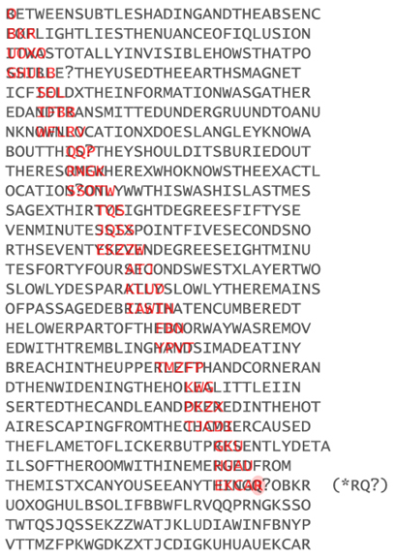(cont’d)

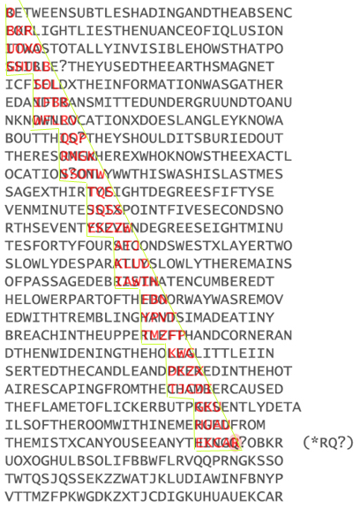
Note: step-pyramid interior, with smooth surface, just like the pyramids at Giza used to be. Coincidentally ENDING right at the question mark preceding K4?

Granted, Carter Found Tut’s tomb in the Valley of the Kings, NOT at Giza, but this is working on the Golden Ratio idea and it’s relation to the difference between the coordinates in K2 and the ACTUAL coordinates.

Next step: unravel the layered letters? Go through various options of already suggested transformations of K4 to see if transposing in this manner is meaningful?

Drawbacks: Doesn’t definitively address misspellings, or other enigmatic portions of the cipher.

In addition, there are several “words visible,” however, given the letter frequencies in the text, that is highly probable, especially for the 3-letter words I see. Originally, when I started to set this up, the vertical word B-U-G-S appeared at the top left of the assemblage. While I imagined scarab beetles running out of the “tomb,” ala “The Mummy”, there is no description of this occurring in the actual journal of Howard Carter, NOR his later book on the dig.
Even if this brings no new fruit to the puzzle, I’m an archaeologist, and this was FUN.

☺

